Date

Name
Address
City

Dear

Thanks to you and other generous supporters, the McLeod Foundation has been able to continue funding programs that have ensured both excellent and compassionate healthcare for our region.

The arrival of the New Year brings a time of reflecting on the lives we've led--our accomplishments, our failures, our hopes and our dreams. We may ask ourselves if we have done anything to make the world a better place. Will there be some sign after we are gone that we made even a slight difference?

Your life's accomplishments can be used to leave a legacy of caring for others that may influence your family for generations. This can only be achieved if you take the steps necessary to ensure that your wishes are carried out.

This year two estate gifts were received. One family's wishes to assist McLeod Hospice with extending compassionate end-of-life care will be fulfilled. Another couple's generosity will assist the efforts to provide the most advanced cancer services in the region. Both gifts are truly life changing legacies.

To help you consider your plans for the first time or review plans you may already have in place, I have enclosed a brief quiz. These strategic questions will guide you to make sure that all areas of your plan have been considered.

As a valued donor to the McLeod Foundation, I urge you to take advantage of the resources available to you. These include our website (www.mcleodfoundation.org and click on Planned Giving) or brochures with extensive information that can be mailed to you. We can also offer you a free one hour confidential no obligation consultation with our planned giving consultant to help guide you.

I hope you will contact me if I can help provide you with any of these resources or answer any of your questions. You are important to us and we are here to assist you.

Yours truly,
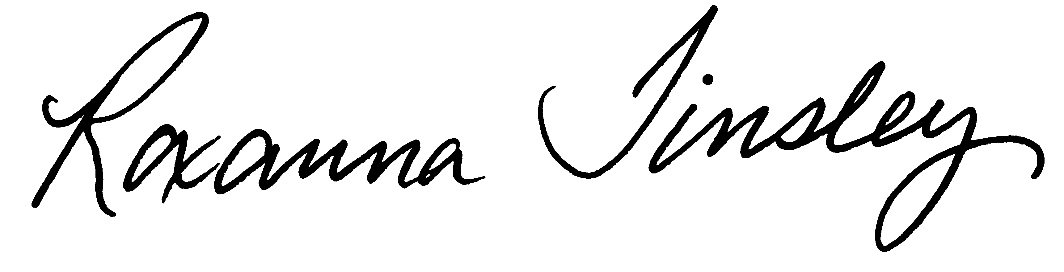
Roxanna Tinsley
Development Officer

